**CIS 2170 - Lab 2**

**Soohwan Kim**

**1349765**

**Lab Section 1**

**January 22, 2025**

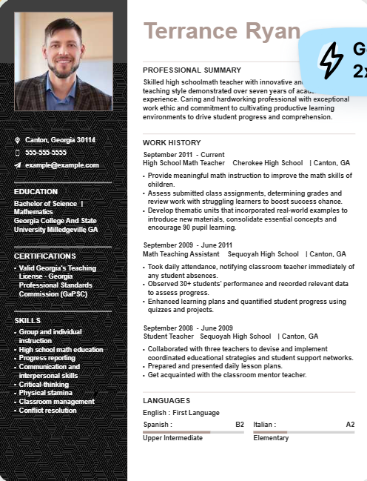

**Why I like the example:**

**Layout and Organization:**

I appreciate the overall layout of the resume. Having the photo and essential personal information on the left-hand side, while keeping the summary and professional experience on the right, creates a clear and logical structure. This arrangement makes it easy for the reader to scan through the critical details quickly, which is essential for capturing attention. Additionally, this format is visually appealing and eye-catching, giving the resume a polished and professional feel.

**Color Scheme:**

The color scheme used in the example is one of its strongest aspects. The colors are neither too bright nor overwhelming, but instead soft and visually comfortable. This choice of color makes the resume easy to read and pleasant to look at. A well-chosen color palette, like the one used here, can leave a lasting positive impression on the reader and convey a sense of professionalism and creativity.

**Subtle Graphics and Details:**

I particularly like the subtle graphics and background elements on the left side of the resume. These small design details add a unique touch and help the resume stand out without being too distracting. Such thoughtful design choices can make the candidate more memorable, as they demonstrate attention to detail and a flair for creativity.

My resume

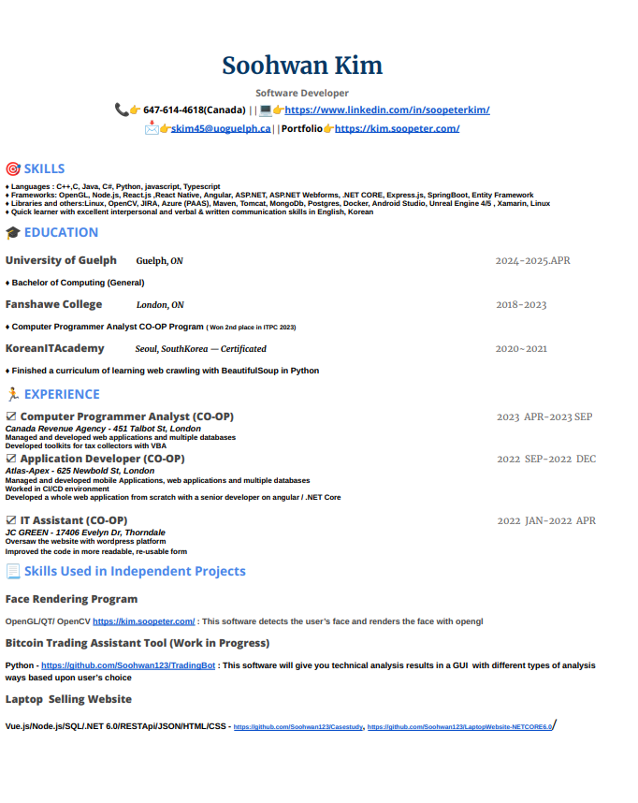

**3 Principles That My Resume Uses Well**

**Alignment:**

One of the strongest aspects of my resume is its alignment. The text and sections are well-organized, and nothing feels out of place or misaligned. Proper alignment creates a clean and professional look, ensuring that the information is presented in an orderly and visually appealing way. This makes the resume easy to read and navigate for the recruiter or hiring manager.

**Color:**

The color scheme of my resume is perhaps its most effective feature. By incorporating soft tones of blue and green, I have created a design that is both visually soothing and professional. These colors are known for their calming effect on the eyes, and they also convey a sense of trust and stability. The balance of color adds to the resume’s appeal without overshadowing the content.

**Balance:**

The overall balance of the resume is another notable strength. Each section is given appropriate weight and space, and no part of the resume feels too overwhelming or cluttered. This balance ensures that the content flows naturally and the reader's attention is guided seamlessly from one section to the next. A well-balanced layout communicates a sense of professionalism and care in design.**2 Principles that this resume uses well**

**3 Design Principles that my Resume Does Not Use Well:**

**Contrast:**

While the overall design of the resume is clean and balanced, it lacks effective use of contrast. The consistent styling and color choices, while visually cohesive, fail to create standout elements that draw the reader's attention. Key sections such as achievements or skills do not pop out and can easily blend in with the rest of the content. Effective contrast could have been used to highlight important details and guide the reader's eyes to the most crucial information, which is an opportunity this resume missed.

**Variety:**

The resume's design is undoubtedly balanced and consistent, but this comes at the cost of variety. The uniform structure and repetitive elements make the overall layout feel somewhat monotonous. There is little variation in typography, section layout, or graphic elements, which makes the design appear dull. Adding more variety—such as subtle changes in font size, bold headings, or different section dividers—could make the resume more engaging and memorable.

**Critiquing Resumes In The Group**

Noah Lim’s Resume

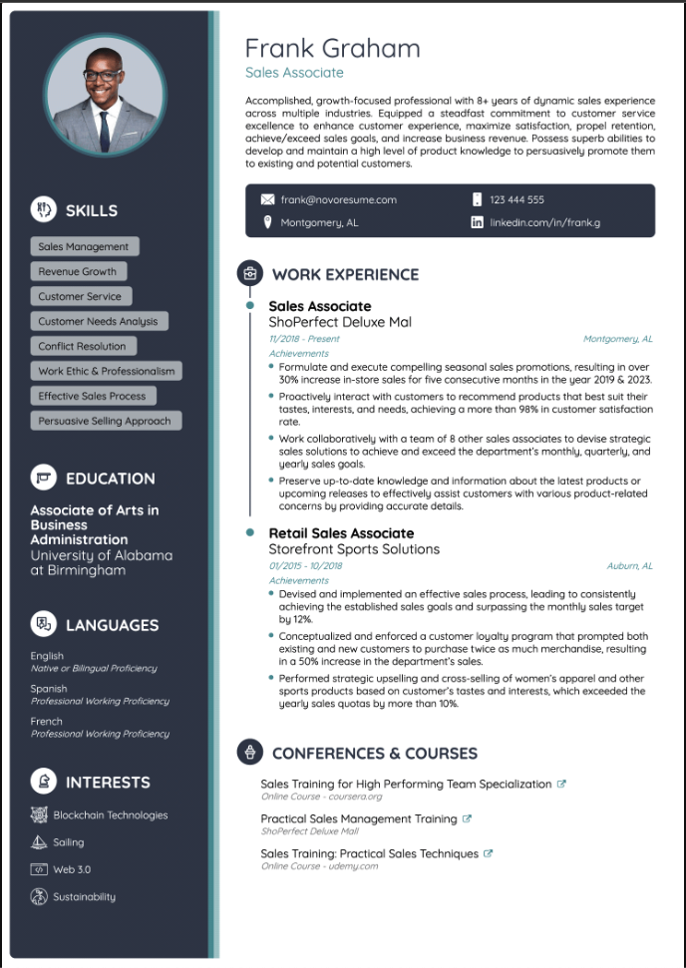

**Needs of Improvement**

1. The color choice could be better

2. There could be more use of movement within the resume to add more depth

Dylan Gaspar’s Resume

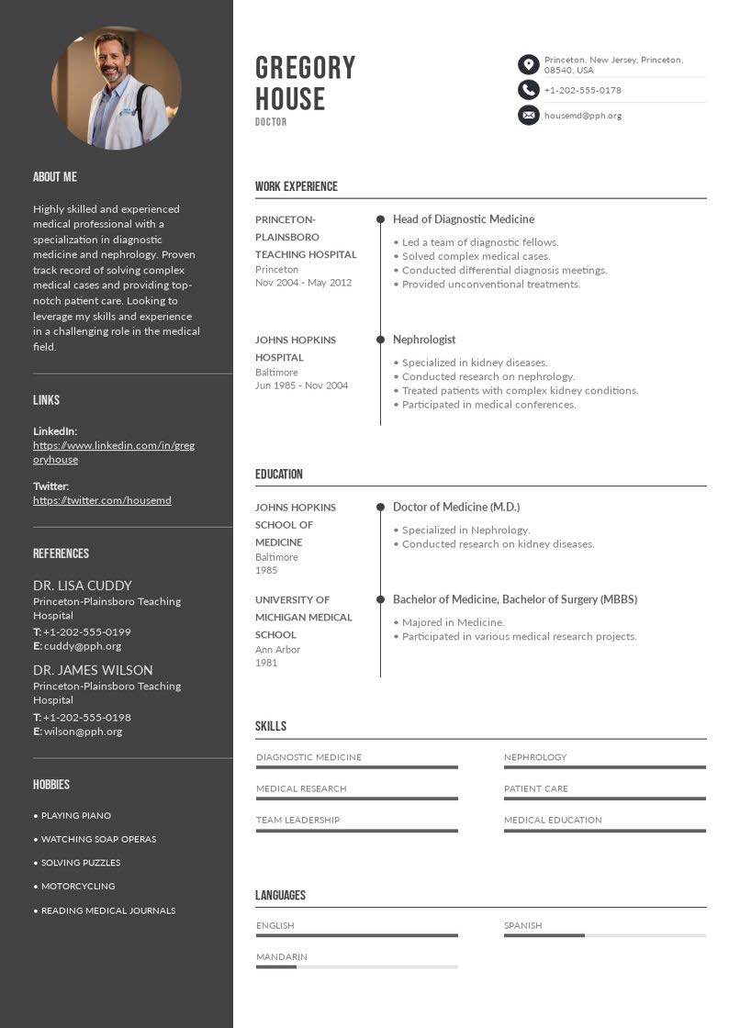

**Needs of Improvement**

1.Not a lot of color, can add more color for better contrast.

2.Low proximity on left side, words are really squished together and not a lot of spacing

Connor Hodgson’s resume

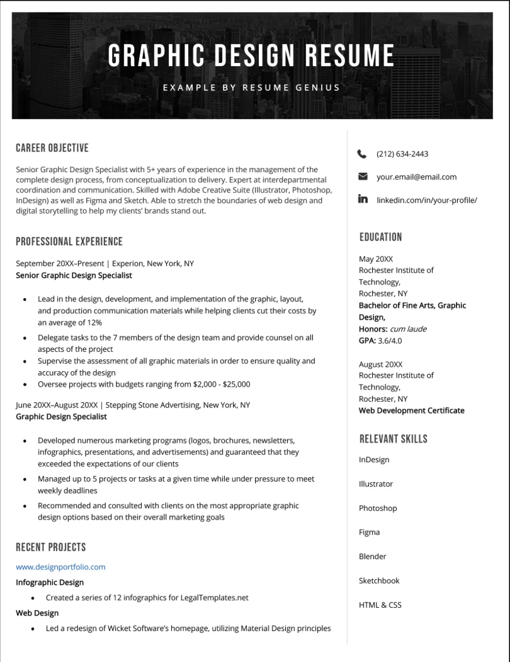

**Needs of Improvement**

1.It lacks color and is not very interesting to look at. Adding colors could help add emphasis for important information

2.It needs more variety since it’s too bland and consistent.

**Best Resume( The Resume to use for updating my resume )**

Dylan Gaspar’s Resume



We chose this resume as the most visually appealing because of its clean use of lines, effective color scheme, and well-thought-out alignment. The font choice enhances readability, and the overall design feels professional and balanced. These elements work together to create a polished and eye-catching layout.

**My Updated Resume**

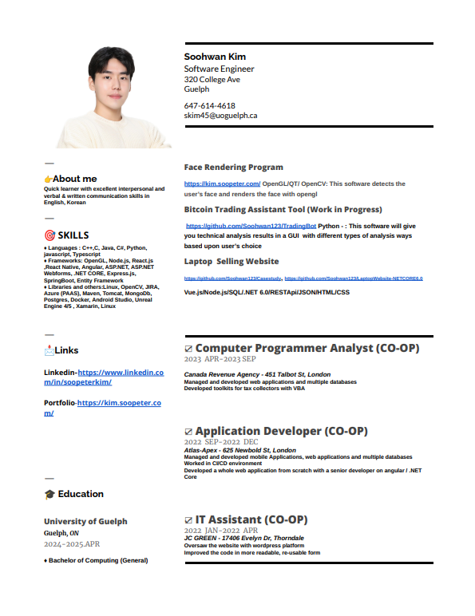

I incorporated appropriate icons to represent the content of each section in my resume. For example, I used a target icon to highlight skills and an envelope icon for contact links. However, I chose not to adopt the color scheme from the best resume, as it worked well with their experience and photo but didn’t complement my content. Instead, I kept the background white for a cleaner look. On the other hand, I did adopt the layout, placing key information on the left and descriptive details on the right for better organization and readability.